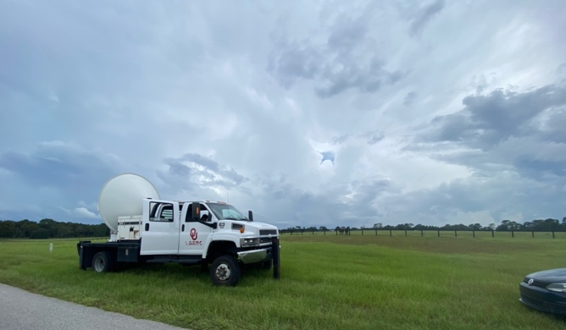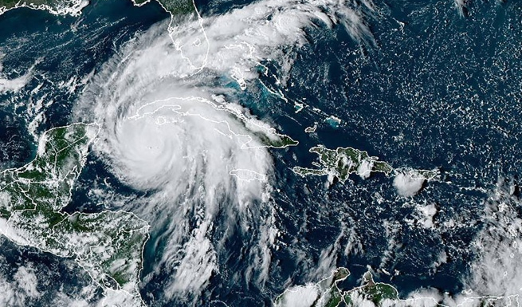
The invention and implementation of radar and satellite technologies during the mid- to late-20th century is arguably the most important revolution to meteorologists’ ability to observe Earth’s atmosphere. The goal of this course is to learn fundamental principles of radars and satellites, with application to observation of meteorological phenomena. To achieve this goal, students will master the basic atmospheric radiation, learn concepts of radar and satellite design and operation, apply imagey interpretation on radar and satellite observation of atmospheric phenomena. Students will have the opportunity to work on research-related labs to increase their ability to utilize remote sensing tools.
The instructor will provide one-to-one programming guidance. All students are expected to know where to download the radar and satellite data, how to process the data, and how to use the data in their daily life and research.

Class
Time: Tuesday, Period 7, 1:55pm-2:45pm (TUR 3006);
Thursday, Periods 6-7, 12:50pm-2:45pm (TUR 3006).
Materials: While no textbook is required, it can be helpful to have a text that will explain concepts in a different way than you get in lecture. The recommended textbook is:
Radar for Meteorologists (Rinehart, 5th edition)
A First Course in Atmospheric Radiation (Petty, Grant W., 2nd Edition).
A portion of the course notes will be supplied through Canvas (elearning.ufl.edu). The notes will be comprehensive, but the books will provide helpful supplementation, and are a good investment for those who plan to major in a related field.

Instructor
Dr. Yixin Wen, Yixin.wen@ufl.edu
My office: Turlington Hall, Geography Department, Room 3203
Office hours: Thursday 10:30-12:30pm. If you want to make an appointment at another time, just email me. I will try to accommodate you as my schedule permits.

Grades
The final grade will be calculated based on the following:
Undergraduate Students:  Lab assignments (6 @10%): 60%  Final presentation: 10%  Exams (2 @10%): 20%  Attendance: 10% | Graduate Students:  Lab assignments (6 @10%): 60%  Final presentation: 10%  Exams (2 @10%): 20%  Research Paper: 10%

Lab assignments
There will be six lab assignments for this class. You are expected to independently solve the problems though discussions among classmates are allowed. I will give you time to work on the lab assignments in class. Please hand in your assignments on the due day. Due dates will be on Canvas. There will be no makeup homework exercises. No late work will be accepted unless an extension is approved due to special circumstances (see Absences).

Exams
There will be two exams. Both exams are cumulative in nature. All material from the beginning of the semester could be included on any exam, though the focus will be on material covered since the previous exam. The last of the regular exams will be held when the final exam is scheduled.

Attendance (for undergraduate students)
Students are expected to regularly attend class and actively participate in discussions.

Research Paper and Presentation (for graduate students)
Graduate students will work to research a topic, of their choosing, relating to weather and climate. The aim will be to produce a literature review or original study paper. The paper may take the form of a summary review, meta-analysis, or original study. The graduate students will also be responsible for presenting their paper to the class. Graduate students will meet with the professor regularly to discuss ideas and progress. More detailed instructions will be provided during class meetings.

Percentages necessary to earn a given final grade are as follows:
 |  | B+ | 87.0-89.9% | C+ | 77.0-79.9% | D+ | 67.0-69.9%
A | 90.0-100% | B | 83.0-86.9% | C | 73.0-76.9% | D | 63.0-66.9%
 |  | B- | 80.0-82.9% | C- | 70.0-72.9% | D- | 60.0-62.9%
Grades will be supplied through Canvas throughout the semester. It is your responsibility to keep track of your grade and contact the instructor if you are struggling with the material.

Class Structure
This is a lecture + lab mixed class. Important material will be covered in every class. We will use a combination of slide presentations, some videos, in-class activities, and labs. You should listen well during class and take good notes for yourself. Lab assignments and quizzes are designed to synthesize material from the lectures and text. Weather and climate are a surprisingly complex topic. We’ll cover many different parts of how the weather and climate works, and you will have to combine these parts to understand how they work together. Attending class and completing the quizzes and homework on time will be key to understanding the material.

Course Goals
Students should be able to identify and describe the concepts, terminology, and tools pertaining to radar and satellite meteorology. This includes:
- Students can demonstrate the ability to describe in class a variety of atmospheric phenomena depicted on radar or satellite imagery.
- Students can demonstrate the ability to relate radar reflectivity to rainfall rate and discuss factors that contribute to the uncertainty in the rainfall rate estimation.
- Students can demonstrate the ability to discuss satellite images.
- Students can access, process, and analyze radar and satellite data
- Graduate students can use radar and satellite data to answer scientific questions.

Schedule The precise dates may change. I will update you as we go.
Week | Tuesday | Thursday | Due
1 | T1_Introduction | T1_Lab setup
2 | T2_History of radar and satellite | T3_Radiation (1) | Lab 1
3 | T4_Radiation (2) | T5_Radiation (3)
4 | T6_Radar fundamental | T7_Radar demo | Lab 2
5 | T8_Radar observations | T9_Radar data visualization
6 | T10_Polarization | T11_Hydrometeoro Classification Algorithm | Lab 3
7 | Review | Midterm Exam
8 | T12_Satellite orbit | T13_Satellite channels
9 | T14_Satellite Cloud Observation | T15_Satellite Images | Lab 4
10 | T16_Satellite Winds | T17_Weather Forecasting
11 | T18_Wild weather (1) | T19_Wild weather (2) | Lab 5
12 | T20_Wild weather (3) | T21_Monitoring the Global Environment
13 | T22_New satellites | T23_Ground Validation | Lab 6
14 | T24_Data Synergy | Final project presentation
15 | Review | Reading Day | Final paper (Grad student)
16 | Finals Week – Friday

Class Notes and Grading
There are many remote sensing and meteorology courses of this nature, and so there may be many notes floating around online. In general, I find online remote sensing and meteorological websites to be less helpful than other common subjects. However, the notes I will provide you, as well as information from legitimate subject-relevant textbooks will be considered as the final authority on matters of grading.

Math Content
The study of radar and satellite meteorology can include some complicated Math! However, any equations that we use with the help from MATLAB will be very basic, explained in detail, and provided to you in lab assignments and/or exams (no memorization needed, although you will need to understand what the equation does). A calculator will not be required in class or for homework or exams unless I tell you in advance.

My Expectations of You
You will read materials for a particular class period either before or shortly after class. Learning often isn’t the most joyous activity because it requires a significant effort. The nationwide standard for university scholarship says students should study (read, review, reflect, practice, do homework) at least 2 hours for every hour you are in lecture.

Though we will be doing some activities that use the internet during class, don’t text message, visit Facebook, browse the internet, etc. during class unless I approve you do so. This is a major distraction from learning for your peers as well.

Web page
The class web page can be found at: elearning.ufl.edu/. If you encounter any problems with the web page, do something (anything!) to let the instructor know.

Academic Honesty
“UF students are bound by The Honor Pledge which states, “We, the members of the University of Florida community, pledge to hold ourselves and our peers to the highest standards of honor and integrity by abiding by the Honor Code. On all work submitted for credit by students at the University of Florida, the following pledge is either required or implied: “On my honor, I have neither given nor received unauthorized aid in doing this assignment.” The Honor Code (sccr.dso.ufl.edu/process/student-conduct-code/) specifies a number of behaviors that are in violation of this code and the possible sanctions. Furthermore, you are obligated to report any condition that facilitates academic misconduct to appropriate personnel. If you have any questions or concerns, please consult with the instructor in this class.”

Accommodations
“Students with disabilities who experience learning barriers and would like to request academic accommodations should connect with the Disability Resource Center by visiting https://disability.ufl.edu/students/get-started/. It is important for students to share their accommodation letter with their instructor and discuss their access needs, as early as possible in the semester.”

Excused Absences
Requirements for class attendance and make-up exams, assignments, and other work in this course are consistent with university policies that can be found at: https://catalog.ufl.edu/ugrad/current/regulations/info/attendance.aspx

“In general, acceptable reasons for absence from or failure to participate in class include illness, serious family emergencies, special curricular requirements (e.g., judging trips, field trips, professional conferences), military obligation, severe weather conditions, religious holidays, and participation in official university activities such as music performances, athletic competition or debate. Absences from class for court-imposed legal obligations (e.g., jury duty or subpoena) must be excused.”

I appreciate that unexpected events occur in all of our lives. If such events occur, and it causes you to attend an event (e.g., funeral, job interview) or a facility (e.g., doctor’s office, courthouse), then you will need to prove that you went to this event/facility on that date by providing some form of documentation of the event. An event program, a doctor’s note, or similar paperwork will suffice. Upon producing this documentation, you will be able to make up the midterm exam or any graded class activities from that date.

“A student should inform the faculty member of the religious observances of his or her faith that will conflict with class attendance, with tests or examinations, or with other class activities prior to the class or occurrence of that test or activity.”

Grades
UF policies on grades and GPAs can be found at:
https://catalog.ufl.edu/UGRD/academic-regulations/grades-grading-policies/

Course Evaluation
“Students are expected to provide professional and respectful feedback on the quality of instruction in this course by completing course evaluations online via GatorEvals. Guidance on how to give feedback in a professional and respectful manner is available
at gatorevals.aa.ufl.edu/students/. Students will be notified when the evaluation period opens, and can complete evaluations through the email they receive from GatorEvals, in their Canvas course menu under GatorEvals, or via ufl.bluera.com/ufl/. Summaries of course evaluation results are available to students at gatorevals.aa.ufl.edu/public-results/.”

Title IX
For any concerns regarding gender-based discrimination, sexual harassment, sexual assault, dating/domestic violence, or stalking, there are resources available. To learn more or to report an incident, go to: titleix.ufl.edu. A professor/GA/TA is required to report instances of sexual harassment, sexual assault, or discrimination.

Drops, Absences, etc.
Should you decide to drop the course for whatever reason, you must request to do so through the appropriate channels by the appropriate deadlines. You will receive a W for withdrawing. Failing to do so will result in an E grade for the course. If at the time you withdraw from the course you are scoring a failing grade, you will receive an E grade.

Should you need modifications or adjustments to your course requirements because of documented pregnancy-related or childbirth-related issues, please contact the instructor as soon as possible to discuss. Generally, modifications will be made where medically necessary.

Disclaimer
This syllabus represents my current plans and objectives. As we go through the semester, those plans may need to change. I have the right to institute new policies during the semester to ensure safety and a positive learning environment for all students.

