Department of Geography University of Florida
Social Geography
GEO 2410 – Sections 12186 (SGDL) & 18356 (SGUF)
Asynchronous Online Class: Spring 2026
Instructor: Zeyu He
Email: hez1@ufl.edu or via Canvas.
Office hours: Jan. 19– Apr. 17, Friday 10:30 AM - 12:30 AM EST in Turlington Hall 1215 or Zoom
Syllabus design contributors: Neha Kohli, Dr. Michael Waylen & Dr. Heidi Lannon.
Response to COVID-19 and other infectious diseases.
It is recommended that all UF community members follow UF guidance related to COVID-19 and other infectious diseases: https://wellness.ufl.edu.

Student Accommodations
Students requesting accommodations are required to register with the Disability Resource Center (352392-8565, https://dso.ufl.edu). Once registered, students will receive an accommodation letter which must be presented to the instructor. Students with disabilities are strongly advised to follow this procedure as early as possible in the semester.

Counselling and Wellness Center
Please do not hesitate to reach out to the Counseling and Wellness Center if you feel you may need their services: https://counseling.ufl.edu, 352-392-1575; or to the University Police Department: 352392-1111 or 911 for emergencies.

Online Participation Policy
Since the pedagogical approach of this course relies on student interaction, you are required to participate in all class activities including those that require interaction with peers. Instructions on weekly activities will be made available on Canvas via the syllabus, announcements, or posts.

Class Attendance and Behavior Policy
If you are unable to take the class at any time due to extenuating circumstances, it is required that you inform the instructor by email in advance of the time you plan to be absent. Even though this is an asynchronous class, students should respect each other’s opinions and contributions and maintain a congenial learning environment on Canvas.
The instructor will use University of Florida email and the class Canvas platform to communicate with students about the course. Students are expected to check Canvas for any updates and information. Professional language should be used in all communication. Students are advised to use office hours to discuss any doubts about the syllabus or class materials as you engage with them.

This course complies with all UF academic policies. For information on those polices and for resources for students, please see this link.

Course Description
Societies involve human as well as more than human interactions across space. The photo below reflects society coming into relation with the built environment such as freeways and the natural environment such as creeks that are ‘hidden’ by the built environment. Relations like these produce social effects that may vary from place to place and affect people differently. For instance, while freeways may be accessible and beneficial to certain populations, they may curtail access to ‘hidden’ creeks required by populations that have different societal needs. These relations may also change over time. Social Geography provides an analytical lens to critically examine these uneven effects and changes using key concepts like space and scale while engaging with social issues such as migration and environmental justice. It asks questions about how certain developments in society occur spatially, who might they benefit or leave out and how. Each week involves either labs, quizzes, or discussions via responses to class materials of the module of the week. Students are expected to complete the assigned readings of each week during the week that they are assigned and submit responses to discussions by the end of the week on Friday. Since this is an asynchronous online class, lab and quiz assignments can be submitted at leisure, though it is strongly encouraged that they be submitted by the recommended due date of Friday of the week that they are assigned. However, discussion posts and the final assignment on the project proposal outline must be submitted by the Friday of the week that they are due. Please consult the class modules on Canvas at the start of each week.

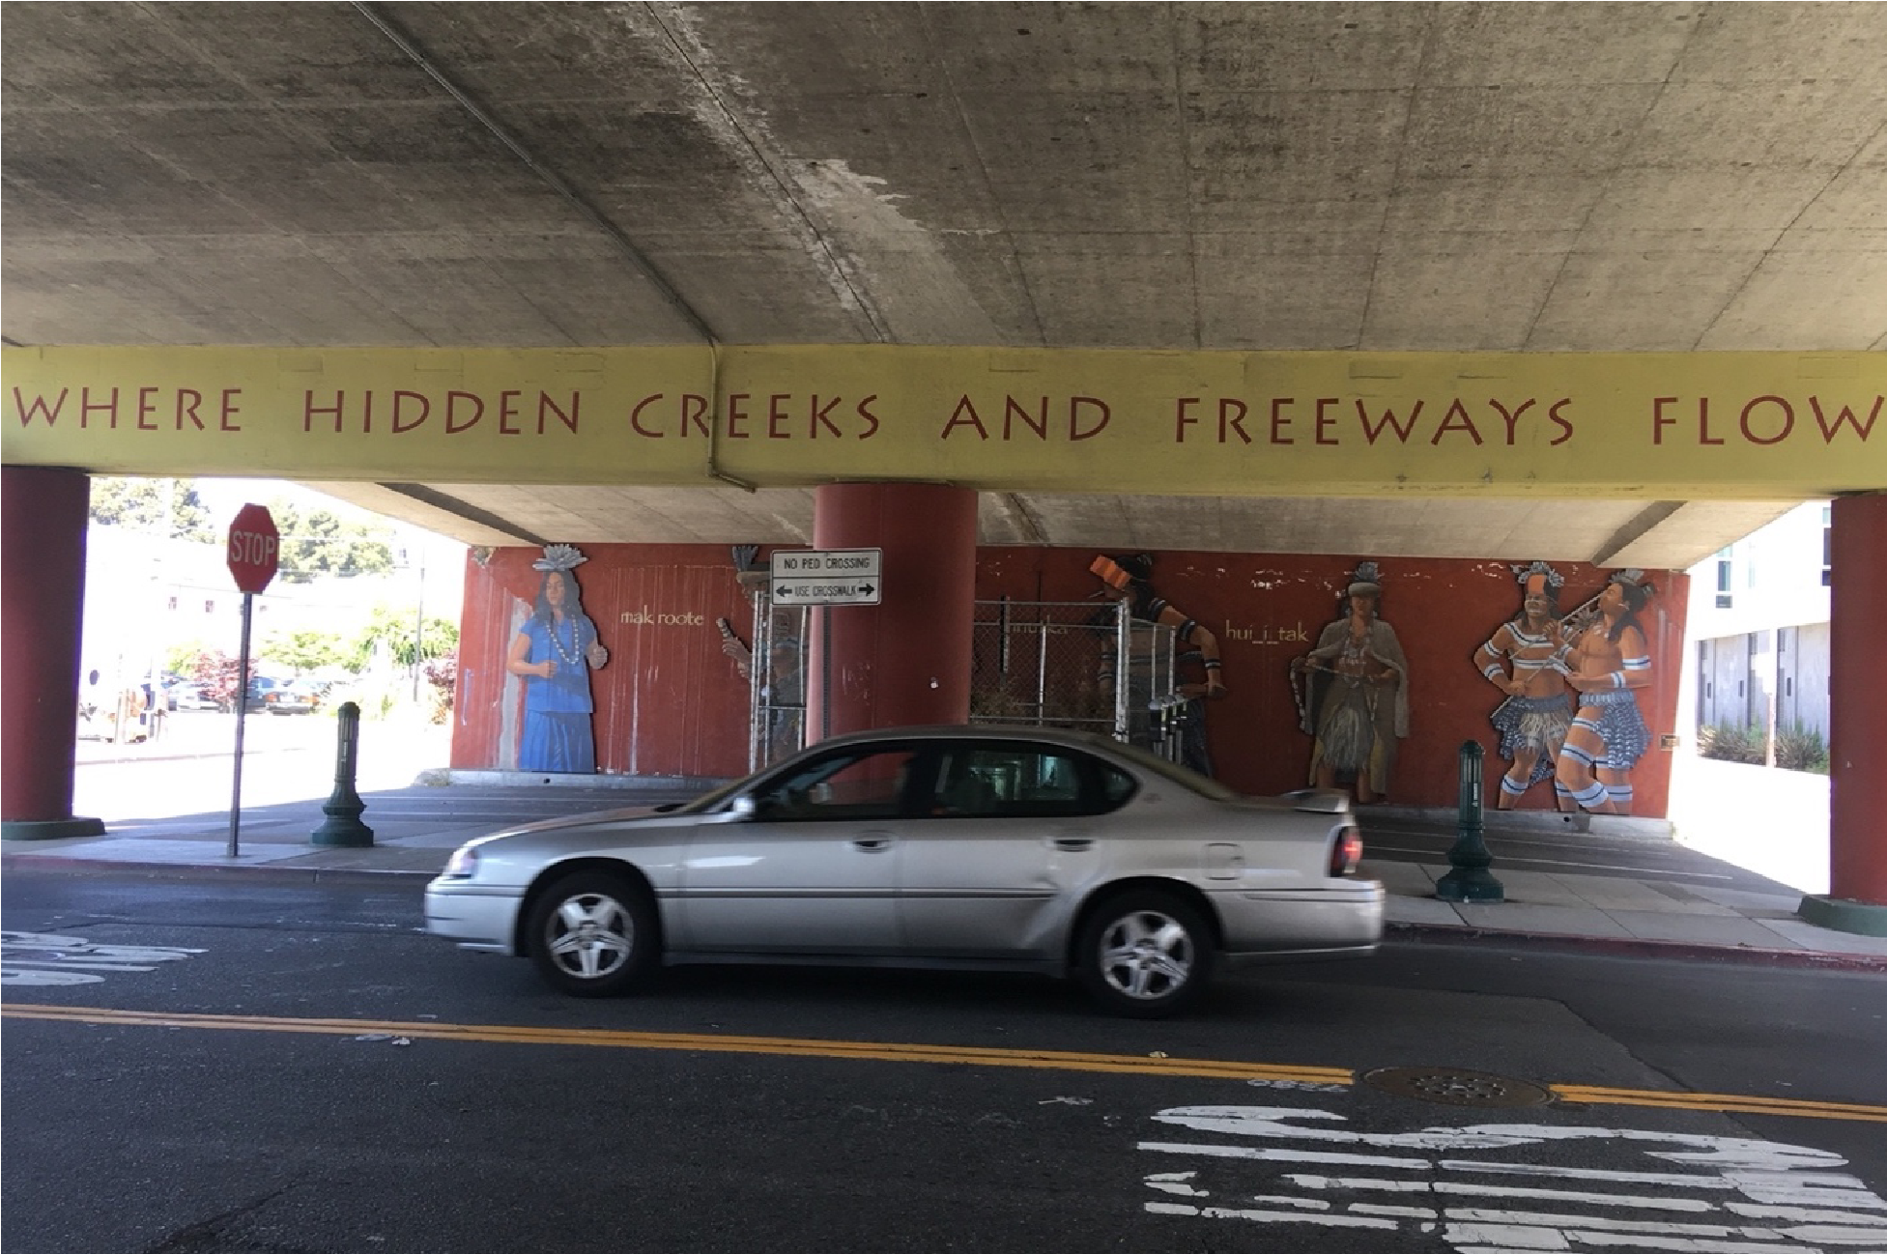
Berkeley, CA, USA. Photo. Neha Kohli.

Course Objectives
- Articulate what Social Geography is and what its role is as a social science discipline.
- Understand key concepts and theoretical and methodological approaches in Social Geography and learn to apply them to real-life situations across societies and landscapes around the world.
- Gain awareness of how social systems operate spatially and develop an appreciation for the complexity of structural processes that shape social outcomes.
- Learn to communicate a well conceptualized, analytical, and critical reflection.
- Gain appreciation for working and learning with peers.
- Learn to conceptualize social science based geographic research design.

Required Texts:
- The Newcastle Social Geographies Collective. 2021 *Social Geographies: An Introduction. Rowman & Littlefield Publishers. ISBN: 9781786612304.
*Book available at the publisher’s website to purchase. The e-book can be purchased from the publisher’s website at 30% discount with code STUDENT30.
- Other materials such as web links and articles will be made available as links or PDF via Canvas.
Instructional materials for this course consist of only those materials specifically reviewed, selected, and assigned by the instructor(s). The instructor(s) is only responsible for these instructional materials.

Assignments
The final course grade will be evaluated upon completion of the following tasks. All discussion post deliverables as well as the final assignment on the project proposal outline need to be submitted by 11:59 PM on the Friday of the week that they are due. Late submissions of discussion posts, and the final assignment will not be considered. Note that while there is no penalty for late submission of lab and quiz-based assignments. However, for the successful completion of the course and to keep track of your progress in class, it is strongly recommended that you submit the lab and quiz-based assignments by the recommended due date of Friday of the week that they are assigned. Detailed guidance on deliverables, if necessary, will be provided on Canvas.

1. Weekly deliverables: 75 points (5 points each week for the first 15 weeks)
- On Monday of each week students are expected to consult the module of the week for assigned materials and the deliverables of the week. The deliverables for each week may either be one of or a combination of a discussion post, quiz, or/and a lab assignment.
- The discussion posts, unless mentioned otherwise on Canvas*, are meant to be a critical reflection of at least 200 words and no more than 350 words. Each reflection will be assessed based on critical engagement with the course materials, clear writing, and application of knowledge acquired from the class materials. In addition, each student is expected to respond critically to a discussion post of at least two other students’ reflection such that any point of agreement or/and disagreement must be respectful and accompanied by an explanation. The responses should be at least 50 and no more than 100 words. *For instance, this does not apply to the discussion on class introductions in the first week.
- By Friday, each student is expected to engage in the activity of the week. This may be a quiz or a lab assignment. Each week’s activities will be assessed based on following the guideline for the activity that will be made available on Canvas.

Project Proposal Outline: 25 points
- This assignment involves writing an outline of a research project proposal on an issue related to Social Geography. You will be evaluated on an outline of the following sections: an abstract, introduction, literature review, proposed research that includes the theoretical and methodological approach, expected outcomes and bibliography. You will not actually be conducting the research. The purpose of the proposal is to think about the process of social science research design.
- The assignment asks you to engage with a particular issue, which could include questions about discourse, patterns of behavior, events, beliefs, or attitudes that shape social interactions. The issue must be related to ‘divisions’ and ‘issues’ covered in class or/and by the textbook. Students are advised to start thinking about this from the start of the course.
- The project can be done in a group of two students or individually. If you do the project in a group, the same must be communicated to the instructor via Canvas no later than Mar. 23.
- In preparation for the project, data that you will use for your project needs to be determined to generate geographic information. Data may be primary in nature, such as from conducting an online survey; or secondary in nature, such as from the census or published literature. It can also be based on visual imagery like films, GIS, or remote sensing. You may also use both primary and secondary data.
- The outline of the project proposal will be assessed based on clarity and structure, use of key concepts as discussed in Parts B and C of the textbook, engagement with class materials, critical reflection, and originality of project idea. The submission should be uploaded on Canvas by 11:59 PM in May. 1, 2026. All written assignments may be evaluated using Turnitin.com originality-checking software.
Evaluation of Grades
Summary of Assignments | Total Points | Percent of Grade
Weekly deliverables | 75 | 25
Term Project | 25 | 25%
Total | 100 | 100%

Grades will be awarded according to scores in percentage listed below:
93-100: A (4.0) 90-92.9: A- (3.7) 87-89.9: B+ (3.3) 83-86.9: B (3.0) 80-82.9: B- (2.7) 77-79.9: C+ (2.3) 73-76.9: C (2.0) 70-72.9: C- (1.7) 67-69.9: D+ (1.3) 63-66.9: D (1.0) 60-62.9: D- (0.7) Less than 60: E
A minimum grade of C is required for general education credit.
More information on grading policies can be found here:
https://catalog.ufl.edu/ugrad/current/regulations/info/grades.aspx

Course Schedule
Week | Date | Module | Readings and Deliverables (D)
1 | Jan 12 - 16 | Introduction  Course overview | Introductions and perceptions of Social Geography  D: Discussion 1

Week | Date | Module | Readings and Deliverables (D)
2 | Jan. 19 - 23 | Introduction to Social  Geography | Select texts from Part A of textbook Chapter 1-3  D: Quiz 1 and Lab 1.
3 | Jan. 26 - 30 | Society and space | Case study discussion. Part B of textbook, Chapter 4  D: Discussion 2
4 | Feb. 2 - 6 | Social Geography key concepts: space, scale, and time. | Chapter 4-6 from textbook and select readings by Drs. Yi Fu Tuan and Edward Soja.  D: Quiz 2 and Lab 2
5 | Feb. 9 – 13 | Space, design, and the city | Case study discussion  D: Discussion 3
6 | Feb. 16 – 20 | Identity and nationalism | Chapters 7-9 from Part B of textbook and select readings on Canvas.  D: Quiz 3 and Lab 3
7 | Feb. 23 – 27 | Indigeneity | Select materials and text by Dr. Deondre Smiles. Chapter 8, 9 form Part B of textbook  Discussion 4
8 | Mar. 2 – 6 | Making space in everyday life | Chapters 10-12 from Part C of textbook and select readings on Canvas.  D: Quiz 4
9 | Mar. 9 – 13 | Uneven geographies | Chapter 13- 15 of textbook and select readings on Canvas.  D: Discussion 5
10 | Mar. 16 – 20  (Spring break) | Borders, migration, mobility, and islands | Chapters 25 & 26 of textbook, an excerpt from an interview with Dr. Erik  Swyngedouw and an address by Dr. Alison Mountz  D: Discussion 6  Proposal Abstract

Week | Date | Module | Readings and Deliverables (D)
11 | Mar. 23 - 27 | Bodies, Sexuality, Disability and Space | Chapters 16-18 of textbook, select article and book chapters by Dr. Doreen Massey.  D: Discussion 7  Proposal Introduction
12 | Mar. 30 – Apr. 3 | Intersectionality | Part C of textbook including chapters 19 and 20 and select texts.  D: Lab 4  Proposal Literature Review
13 | Apr. 6 – 10 | Environmental Justice: a critical approach. | Select chapters from book on critical environmental justice by David Pellow. Select movie and text by Dr. Pavithra Vasudevan and William A Kearney. Part D of textbook including chapters 32-34  D: Quiz 5  Proposal Bibliography
14 | Apr. 13 – 17 | Environmental Justice/Injustice | Select text by Dr. Kyle Whyt  D: Discussion 8
15 | Apr. 20 - 24 | Climate Justice | Select text by Dr. Farhana Sultana  D: Quiz 6  Project Proposal
16 | Apr. 27 – May. 1 | Project proposal outline | Develop the expected outcomes and refine all sections into a complete and compelling proposal.

Assignment Make-Up Policy
Students should arrange with the instructor for makeup material, if circumstances allow it; the student will receive one week to prepare for any makeup assignment that has a due date. Students are expected to approach each week of class prepared and should demonstrate participation. Students are expected to turn in assignments with due dates on time. Late assignments that have a due date will not be considered for a grade. All assignments with a recommended due date must be turned in no later than May. 1, 2026.
University of Florida Honesty Policy:
UF students are bound by The Honor Pledge which states, “We, the members of the University of Florida community, pledge to hold ourselves and our peers to the highest standards of honor and integrity by abiding by the Honor Code. On all work submitted for credit by students at the University of Florida, the following pledge is either required or implied: “On my honor, I have neither given nor received unauthorized aid in doing this assignment.” The Honor Code, which can be found at https://sccr.dso.ufl.edu/policies/student-honor-code-student-conduct-code/, specifies a number of behaviors that are in violation of this code and the possible sanctions. Furthermore, you are obligated to report any condition that facilitates academic misconduct to appropriate personnel.

Course Evaluation
Students are expected to provide feedback on the quality of instruction in this course by completing online evaluations at https://gatorevals.aa.ufl.edu. You will be notified when evaluations are open once in the middle of the semester and another time towards the end of the semester.

Subject to Change Statement
Information contained in the course schedule may be subject to change if advantageous for learning.
Students will be given advance notice as deemed appropriate by the instructor.

